Want to Raise Thousands of Dollars for Adoption Agencies and
Crisis Pregnancy Centers in Illinois?
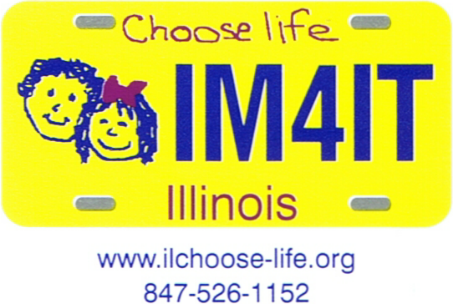
That's right! You could help the pro-life adoption efforts in Illinois receive
thousands of dollars every year.

Choose Life, Inc. has been successful in getting the Choose Life license plate approved in 27 states as of August 2010. Legislative initiatives to create Choose Life license plates are moving in another 18 states on top of this. The tags have been available in Florida since August 2000 and have already sold or renewed over 378,000, raising over $7,500,000. The license plate continues to raise over $58,000 every month.

In Illinois, the money raised yearly from the sale of the Choose Life Specialty License Plate will be returned to the county where the license plates were sold. The money will be distributed to any not-for-profit, non-governmental agency, not involved with abortion, who offer their services free, to pay the expenses of women with an unplanned/unwanted pregnancies, who are committed to carrying their children to term and making adoption plans for those children.
Many pro-life agencies in Illinois could use a program like this!

The money raised by the sale of these license plates in Illinois could exceed a million dollars in a year. Wouldn't it be wonderful to raise a million dollars a year for these women and children? The funds raised could be used to provide for ultrasound services.

Want to see this happen in Illinois? Please read on.

If you would like to be involved in such an effort in Illinois, please contact us. We will welcome your help. We believe this is an idea whose time has come and we are committed to spreading it throughout Illinois. The Choose Life tag is already available in our border states: Indiana, Kentucky and Missouri. With Wisconsin and Iowa in process of obtaining approval, Illinois can be next.

Illinois Choose Life is an Illinois not-for-profit corporation. All workers are volunteers and no one receives any compensation for services performed. We are an IRS 501(c)(3) tax exempt agency and all donations are tax deductible. The corporate address of Illinois Choose Life is:
460 East Lake Shore Drive, Barrington, Illinois, 60010.

Visit the Illinois Choose Life website at: www.ILchoose-life.org.
Visit national Choose Life, Inc. at: www.choose-life.org.

