ILLINOIS  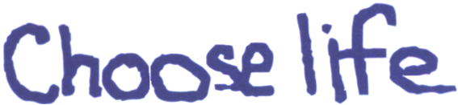  Adoption: The Loving Option  460 E. Lake Shore Dr.  Barrington, IL 60010  847-526-1152  President  James P. Finnegan  Board of Directors  Virginia McCaskey  Richard and Sue Bergquist  James P. Finnegan  Board of Advisors  Barbara Baumhart  Dr. Robert & Eileen Dolehide  Al & Betty Eberhardt  Robert Eckland  Dan & Sandy Gura  Dr. John & Mary Anne Hackett  Rev Tim & Denise Harlow  Michael & Janice Hourihane  Becky MacDougal, LCSW  Tony & Marian Masella  Sen. Patrick O'Malley  Tom & Bethany Morrison  Tom Roeser  Arlene Sawicki  Antigone Sharris  Rev. John Smythe  Mr. & Mrs. Richard Stanek  Msgr. Kenneth Velo  Joe & Carol Walsh  Richard & Audrey Walsh  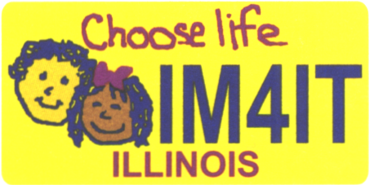  www.ilchoose-life.org | August, 2010  Dear Friend,  $7.3 million to support adoption.  That is how much money Florida residents have voluntarily contributed to adoption service providers over the last decade through the purchase of the “Choose Life” specialty license plate the State of Florida offers to its residents.  Following Florida’s lead, 24 additional states have “adopted” the “Choose Life” license plate as a purchase option for their residents. Legislative initiatives to create “Choose Life” license plates are moving in another 21 states on top of this.  However, as seemingly is the case on so many issues, Illinois is the bad example.  I founded the Illinois Choose Life organization in July 2002 to bring these plates to Illinois in support of the amazing adoption agencies, crisis pregnancy centers, and homes for unwed mothers that work tirelessly to find and to foster loving, nurturing homes for children.  Eight years later, I am still surprised that such an obviously redeeming mission could be so beset by politics.  We tried for three years, in legislative session after legislative session, to get a simple up or down vote on the “Choose Life” plate and, despite ever-increasing numbers of sponsors, each year our bill was bottled up in committee by the powers-that-be in Springfield.  With more than 50 specialty plates in circulation in Illinois, it was clear that certain legislators simply didn’t like our message which is an unjust abridgment of the First Amendment rights of Illinois residents. We took our case to federal court and prevailed at the district court level only to have that verdict overturned on appeal after the Secretary of State and Attorney General convinced the General Assembly to change the law with their appeal pending. Of course, that change in the law did nothing but provide thinly veiled cover to block the “Choose Life” plate and continue the state’s practice of viewpoint discrimination.  As Andrew Carnegie once said, “Anything in life worth having is worth working for.” And so our work continues in earnest.  According to our estimates, within five years of availability, the “Choose Life” license plate would generate more than $1 million annually for adoption service providers in Illinois. This “Choose Life” plate is worth having and we are going to keep working for it.  There is reason for optimism, particularly if we get the leadership changes in Springfield we need in November.

As such, we are re-launching our “Choose Life” license plate petition effort. And I’m asking for your help to reach our goal of 25,000 signatures to bring to Springfield in January, 2011.

Please sign the enclosed petition. Feel free to make copies. You can also download copies of the petition from our website, www.ilchoose-life.org. Please note that it is critical to obtain, if possible, both (1) the signer’s email address so we can communicate with them, send e-updates; and (2) the signer’s indication that they would purchase the “Choose Life” plate if it was made available (check the box).

I am very thankful that the Illinois Family Institute has signed on to help us with this endeavor. The dedication of IFI’s staff and volunteers is truly a blessing for our initiative.

Please do what you can to gather signatures and spread the word within your circles of influence—church, civic/philanthropic organizations, local crisis pregnancy centers (the beneficiaries of this effort), family, friends and neighbors.

In addition to the 25,000 signatures, we want to get signatures from all 102 counties in Illinois to demonstrate the broad support and sizable demand that exists for “Choose Life” license plates.

Christ has asked us to "Go out to all nations and preach the Gospel." Certainly the Gospel of Life would be at the top of His list, a noble and satisfying effort.

Thank you in advance for your consideration and support of bringing the “Choose Life” specialty license plate to Illinois in service of mission to see that every child in Illinois grows up in a loving home.

May God bless you and may He bless our effort.

Sincerely,
Jim Finnegan
President, Illinois Choose Life
(847) 526-1152
jimpfinn@aol.com
www.ilchoose-life.org

P.S. Our goal for the “Choose Life” plate petition effort is 25,000 signatures as soon as possible. Again, please see the enclosed petition form. Feel free to make copies. You can also download copies of the petition from our website, www.ilchoose-life.org. Please note that it is critical to obtain, if possible, both (1) the signer’s email address so we can communicate with them, send e-updates; and (2) the signer’s indication that they would purchase the “Choose Life” plate if it was made available (check the box).

P.P.S. There will be costs involved in this effort and if you are able, please consider making a tax deductible financial contribution to “Illinois Choose Life”, 460 East Lake Shore Dr., Barrington, IL 60010.

